**E COMMERCE WEBSITE**

Use case diagram:

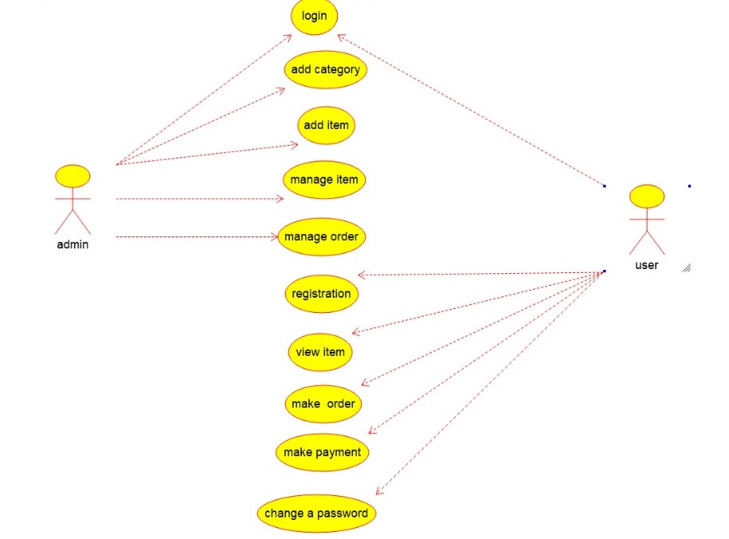

class diagram:

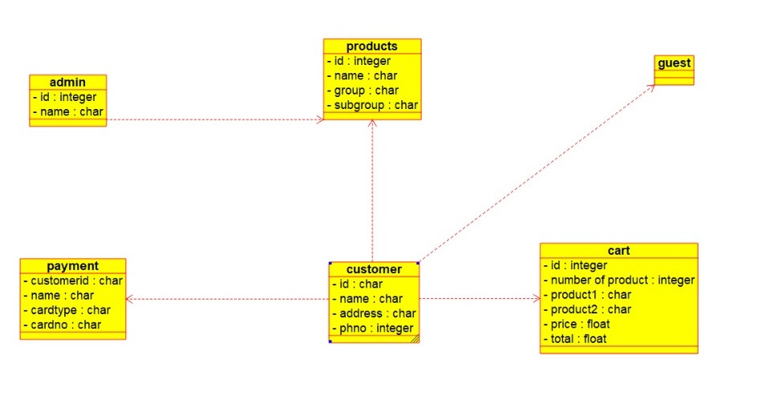

Component diagram:

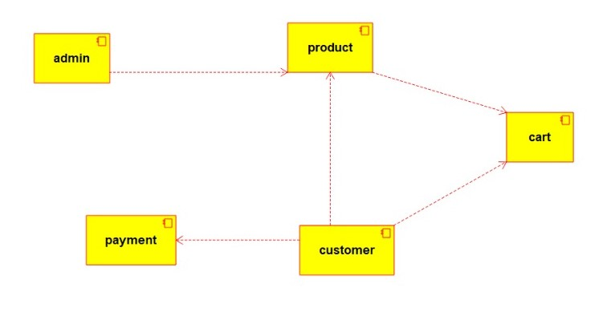

Sequence diagram

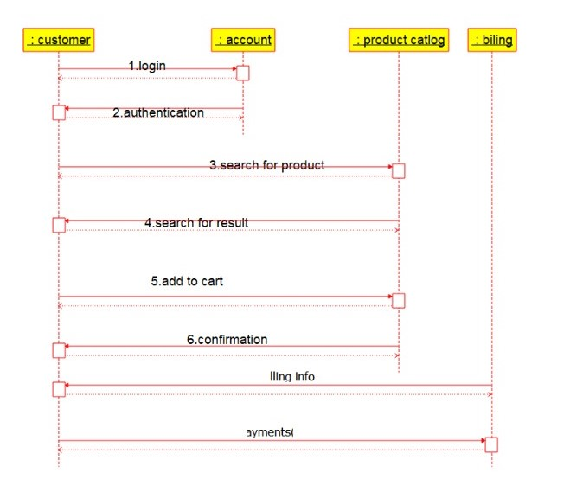:

Collaboration diagram:

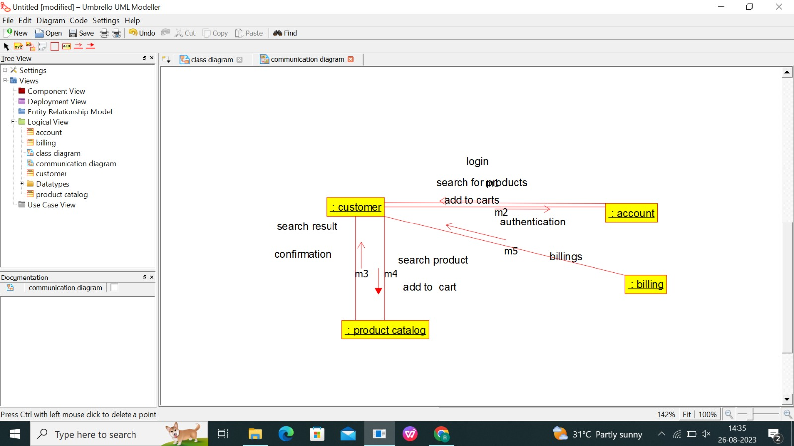

Deployment diagram:

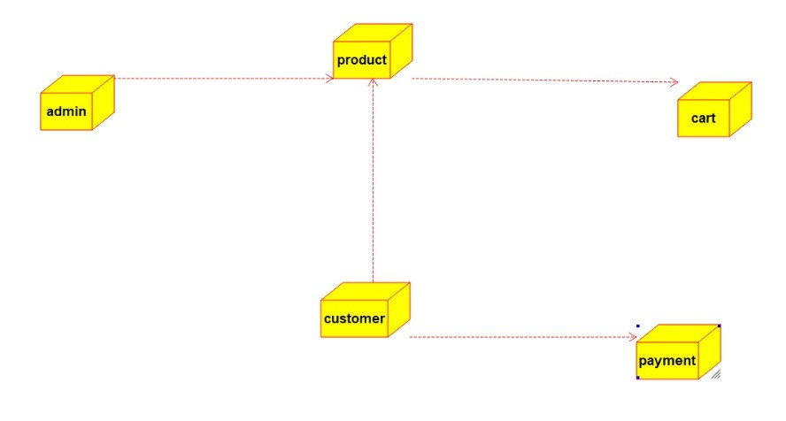

Activity diagram:

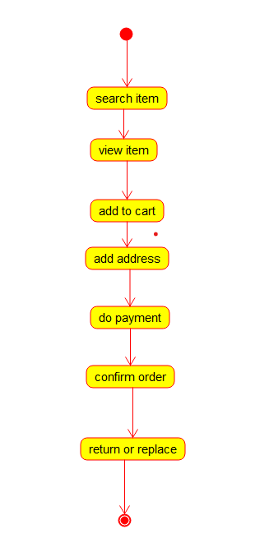

State chart diagram:

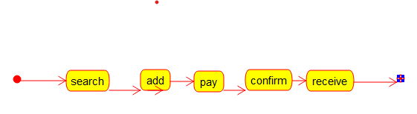

Program:

/**

* Class admin

*/

public class admin {

//

// Fields

//

private integer id;

private char name;

//

// Constructors

//

public admin () { };

//

// Methods

//

//

// Accessor methods

//

/**

* Set the value of id

* @param newVar the new value of id

*/

private void setId (integer newVar) {

id = newVar;

}

/**

* Get the value of id

* @return the value of id

*/

private integer getId () {

return id;

}

/**

* Set the value of name

* @param newVar the new value of name

*/

private void setName (char newVar) {

name = newVar;

}

/**

* Get the value of name

* @return the value of name

*/

private char getName () {

return name;

}

//

// Other methods

//

/**

*/

public void view_product()

{

}

/**

*/

public void add_product()

{

}

/**

*/

public void delete_product()

{

}

/**

*/

public void modify_product()

{

}

/**

*/

public void make_shipment()

{

}

/**

*/

public void confirm_delivery()

{

}

}

/**

* Class products

*/

public class products {

//

// Fields

//

private integer id;

private char name;

private char group;

private char subgroup;

//

// Constructors

//

public products () { };

//

// Methods

//

//

// Accessor methods

//

/**

* Set the value of id

* @param newVar the new value of id

*/

private void setId (integer newVar) {

id = newVar;

}

/**

* Get the value of id

* @return the value of id

*/

private integer getId () {

return id;

}

/**

* Set the value of name

* @param newVar the new value of name

*/

private void setName (char newVar) {

name = newVar;

}

/**

* Get the value of name

* @return the value of name

*/

private char getName () {

return name;

}

/**

* Set the value of group

* @param newVar the new value of group

*/

private void setGroup (char newVar) {

group = newVar;

}

/**

* Get the value of group

* @return the value of group

*/

private char getGroup () {

return group;

}

/**

* Set the value of subgroup

* @param newVar the new value of subgroup

*/

private void setSubgroup (char newVar) {

subgroup = newVar;

}

/**

* Get the value of subgroup

* @return the value of subgroup

*/

private char getSubgroup () {

return subgroup;

}

//

// Other methods

//

}

Payment:

/**

* Class admin

*/

public class admin {

//

// Fields

//

private integer id;

private char name;

//

// Constructors

//

public admin () { };

//

// Methods

//

//

// Accessor methods

//

/**

* Set the value of id

* @param newVar the new value of id

*/

private void setId (integer newVar) {

id = newVar;

}

/**

* Get the value of id

* @return the value of id

*/

private integer getId () {

return id;

}

/**

* Set the value of name

* @param newVar the new value of name

*/

private void setName (char newVar) {

name = newVar;

}

/**

* Get the value of name

* @return the value of name

*/

private char getName () {

return name;

}

//

// Other methods

//

/**

*/

public void view_product()

{

}

/**

*/

public void add_product()

{

}

/**

*/

public void delete_product()

{

}

/**

*/

public void modify_product()

{

}

/**

*/

public void make_shipment()

{

}

/**

*/

public void confirm_delivery()

{

}

}

/**

* Class payment

*/

public class payment {

//

// Fields

//

private char customerid;

private char name;

private char cardtype;

private char cardno;

//

// Constructors

//

public payment () { };

//

// Methods

//

//

// Accessor methods

//

/**

* Set the value of customerid

* @param newVar the new value of customerid

*/

private void setCustomerid (char newVar) {

customerid = newVar;

}

/**

* Get the value of customerid

* @return the value of customerid

*/

private char getCustomerid () {

return customerid;

}

/**

* Set the value of name

* @param newVar the new value of name

*/

private void setName (char newVar) {

name = newVar;

}

/**

* Get the value of name

* @return the value of name

*/

private char getName () {

return name;

}

/**

* Set the value of cardtype

* @param newVar the new value of cardtype

*/

private void setCardtype (char newVar) {

cardtype = newVar;

}

/**

* Get the value of cardtype

* @return the value of cardtype

*/

private char getCardtype () {

return cardtype;

}

/**

* Set the value of cardno

* @param newVar the new value of cardno

*/

private void setCardno (char newVar) {

cardno = newVar;

}

/**

* Get the value of cardno

* @return the value of cardno

*/

private char getCardno () {

return cardno;

}

//

// Other methods

//

}